 

FACE DETECTION IN IMAGE USING DEEP LEARNING

# PROJECT REPORT

***Submitted by***

**ARUN P (311521104302)**

***in fulfillment for the subject***

**NM1009 – GENERATIVE AI FOR ENGINEERING**

**BACHELOR OF ENGINEERING**

***IN***

# COMPUTER SCIENCE AND ENGINEERING MEENAKSHI SUNDARARAJAN ENGINEERING COLLEGE,

**KODAMBAKKAM, CHENNAI-24**

**ANNA UNIVERSITY: CHENNAI 600 025**

# MAY 2024

ANNA UNIVERSITY: CHENNAI 600 025

**BONAFIDE CERTIFICATE**

Certified that this project report “**FACE DETECTION IN IMAGE USING DEEP LEARNING**  ” is the bonafide work of “**ARUN P (3115211040302)** ” Naan Mudhalvan ID **“aut2231150003”** who carried out the project work under my supervision.

**SIGNATURE SIGNATURE**

Dr.S. Aarthi,M.E.,Ph.D Mrs. P.Revathi,M.Tech

**HEAD OF THE DEPARTMENT ASSISTANT PROFESSOR**

Computer Science and Engineering Computer Science and Engineering

Meenakshi Sundararajan Engineering College Meenakshi Sundararajan Engineering College

No.363 , Arcot Road, Kodambakkam , No.363 , Arcot Road, Kodambakkam ,

Chennai- 6000024 Chennai- 6000024

Submitted for the project viva voce of Bachelor of Engineering in Computer Science and Engineering held on___________.

# INTERNALEXAMINER EXTERNALEXAMINER

**ACKNOWLEDGEMENT**

First and foremost, we express our sincere gratitude to our Respected Correspondent **Dr. K. S. Lakshmi**, our beloved Secretary **Mr. N. Sreekanth**, Principal **Dr. S. V. Saravanan** for their constant encouragement, which has been our motivation to strive towards excellence.

Our primary and sincere thanks goes to **Dr. S. Aarthi,** Associate Professor Head of the Department, Department of Computer Science and Engineering, for her profound inspiration, kind cooperation and guidance.

We’re grateful to **Dr. S. Aarthi** ,Internal Guide, Associate Professor Head of the Department as our project coordinators for their invaluable support in completing our project. We are extremely thankful and indebted for sharing expertise, and sincere and valuable guidance and encouragement extended to us.

Above all, we extend our thanks to God Almighty without whose grace and

Blessings it wouldn’t have been possible.

# ABSTRACT

Automated face detection plays a crucial role in various applications such as security systems, image processing, and video analysis. In this project, we implement automated face detection using deep learning techniques in Python with the OpenCV library. The goal is to develop a robust system capable of accurately detecting faces in images uploaded by the user.

We start by downloading pre-trained deep learning model files for face detection from OpenCV's GitHub repository. These files include a deploy prototxt file and a caffemodel file that are necessary for the face detection process. The deep learning model used is based on the Single Shot Multibox Detector (SSD) framework.

Next, we define a Python function to handle the face detection process. This function takes an input image, resizes it for better processing speed, prepares a blob for the deep learning model, and runs a forward pass to detect faces. We set a confidence threshold to filter out low-confidence detections and draw bounding boxes around the detected faces on the image.

The main function of the program handles the user interaction by allowing them to upload an image. It checks for errors such as no file uploaded or errors while loading the image. Once the image is uploaded and loaded successfully, the face detection function is called, and the processed image with detected faces is displayed using the cv2_imshow function from Google Colab.

The implementation leverages the power of deep learning and the simplicity of Python programming with OpenCV to create an effective automated face detection system. The code is designed to be easy to understand and modify, making it suitable for further customization and integration into various projects requiring face detection capabilities.

|  |  |  |
| --- | --- | --- |
|  | **TABLE OF CONTENTS** |  |
| **CHAPTER NO.** | **TITE** | **PAGE NO.** |
|  | **ABSTRACT** | iv |
|  | **LIST OF TABLES** | viii |
|  | **LIST OF FIGURES** | ix |
|  | **LIST OF SYMBOLS, ABBREVIATIONS AND**  **EXPANSIONS** | x |
| **1** | **INTRODUCTION** | **1** |
|  | 1.1 ABOUT THE PROJECT | 1 |
|  | 1.2 PROJECT OVERVIEW | 1 |
|  | 1.3 PURPOSE | 2 |
|  | 1.2 EXISTING SYSTEM | 3 |
|  | 1.3 PROBLEM STATEMENT | 4 |
| **2.** | **LITERATURE SURVEY** | 5 |
| **3.** | **SYSTEM ARCHITECTURE** | 6 |
|  | 3.1 SYSTEM ARCHITECTURE | 6 |
|  | 3.2 HARDWARE REQUIREMENTS | 7 |
|  | 3.3 SOFTWARE REQUIREMENTS | 7 |
|  | 3.3.1 PYTHON | 8 |
|  |  |  |
|  | 3.3.2 JUPYTER NOTEBOOK | 8 |
| **4.** | **IDEATION** | 9 |
|  | 4.1 IDEATION & BRAINSTORMING | 9 |
| **5.** | **REQUIREMENT ANALYSIS** | 11 |
|  | 5.1 FUNCTIONAL REQIREMENTS | 11 |
|  | 5.2 NON-FUNCTIONAL REQUIREMENTS | 12 |
| **6.** | **SYSTEM MODELLING** | 14 |
|  | 6.1 UNIFIED MODELLING LANGUAGE | 14 |
|  | 6.2 USE CASE DIAGRAM | 15 |
|  | 6.3 CLASS DIAGRAM | 17 |
|  | 6.4 SEQUENCE DIAGRAM | 18 |
|  | 6.5 ACTIVITY DIAGRAM | 20 |
|  | 6.6 STATE CHART DIAGRAM | 21 |
| **7.** | **SYSTEM IMPLEMENTATION** | 23 |
|  | 7.1 PROPOSED SYSTEM | 23 |
|  | 7.2 SOURCE CODE | 24 |
| **8.** | **PROJECT DESIGN** | 36 |
|  | 8.1 DATA FLOW DIAGRAM | 36 |
|  |  |  |
|  |  |  |
| **9.** | **ADVANTAGES AND DISADVANTAGES** | 38 |
| **10.** | **CONCLUSION AND FUTURE ENHANCEMENT** | 40 |
|  | 10.1 CONCLUSION | 40 |
|  | 10.2 FUTURE ENHANCEMENT | 40 |
| **11.** | **APPENDIX SCREENSHOT** | 42 |
|  | **REFERNCES** | 45 |
|  |  |  |

|  |  |  |
| --- | --- | --- |
| **TABLE NO.** | **LIST OF TABLES**  **NAME OF THE TABLE** | **PAGE NO.** |
| 3.3 | HARDWARE REQUIREMENTS | 7 |
| 3.4 | SOFTWARE REQUIREMENTS | 7 |

**LIST OF FIGURES**

# FIGURE NO. NAME OF THE FIGURE PAGE NO.

3.2 SYSTEM ARCHITECTURE 6

* 1. USE CASE DIAGRAM 16
  2. CLASS DIAGRAM 18
  3. SEQUENCE DIAGRAM 19
  4. ACTIVITY DIAGRAM 21
  5. STATE CHART DIAGRAM 22

# CHAPTER 1 INTRODUCTION

* 1. **ABOUT THE PROJECT**

This project utilizes deep learning techniques, specifically a pre-trained Single Shot MultiBox Detector (SSD) model, to detect faces in images. Leveraging OpenCV and Google Colab, the code preprocesses uploaded images, converts them into a suitable format for the model, and performs face detection with confidence thresholding. Detected faces are visually highlighted with bounding boxes. This project showcases the seamless integration of deep learning models with computer vision libraries, offering a robust solution for face detection tasks. With applications in security, image processing, and beyond, it demonstrates the effectiveness of pre-trained models in enhancing the capabilities of intelligent systems.

# PROJECT OVERVIEW

**Project Overview:** Deep Learning-Based Face Detection

This project harnesses the power of deep learning for accurate face detection in images. Using OpenCV and Google Colab, it employs a pre-trained Single Shot MultiBox Detector (SSD) model, known for its efficiency in object detection tasks. The workflow begins with uploading an image, which undergoes preprocessing and formatting suitable for the SSD model. Upon feeding the image into the model, face detection is performed with confidence thresholding to ensure reliable results. Detected faces are then visually marked with bounding boxes on the image. This project demonstrates the seamless integration of deep learning models into practical computer vision applications, particularly in tasks like face recognition and surveillance systems.

# PURPOSE

**Educational:** It provides a hands-on learning experience for individuals interested in deep learning, computer vision, and image processing. The project's structure and implementation help users understand concepts such as pre-trained models, blob preparation, confidence thresholds, and bounding box visualization.

**Practical Application**: The automated face detection system can be integrated into real-world applications, including security systems, video analysis, social media platforms, and more. The project demonstrates the practical utility of deep learning in solving complex tasks like face detection.

**Customization and Extension:** The modular design of the code allows for customization and extension. Users can modify parameters, experiment with different pre-trained models, incorporate additional features (e.g., emotion detection, gender classification), or integrate the system into larger projects.

**Efficiency**: By leveraging pre-trained models and optimizing image processing techniques, the project emphasizes efficient face detection, suitable for processing large volumes of images or video streams in real-time or near real-time.

**Demonstration of Technology:** It showcases the capabilities of Python, OpenCV, and deep learning frameworks in developing advanced computer vision applications. The project's documentation and implementation act as a reference for leveraging similar technologies in other projects or domains.

# EXISTING SYSTEM

The existing system for face detection primarily relies on traditional computer vision techniques and machine learning algorithms. Here are the key points regarding the existing system:

**Traditional Computer Vision Techniques:**

Explore the use of traditional methods like Haar cascades, Histogram of Oriented Gradients (HOG), and feature-based classifiers for face detection. Consider their strengths, weaknesses, and limitations in terms of accuracy, scalability, and robustness.

**Machine Learning-Based Approaches:**

Investigate machine learning classifiers such as Support Vector Machines (SVM), decision trees, and ensemble methods used in face detection systems. Assess their performance, training complexity, and generalization capabilities.

**Data Collection and Annotation:**

Consider how face detection datasets are collected, curated, and annotated in existing systems. Explore challenges related to dataset diversity, bias, and data labeling processes.

# PROBLEM STATEMENT

The current face detection systems based on traditional computer vision techniques such as Haar cascades, Histogram of Oriented Gradients (HOG), and machine learning classifiers have limitations in accuracy, robustness, and scalability. These systems often struggle with varying lighting conditions, occlusions, pose variations, and real-time processing. Manual feature engineering and tuning are required, leading to time-consuming development and suboptimal performance in complex environments.

The primary challenges in face detection include:

1. **Accuracy and Robustness:**The existing face detection system based on traditional computer vision techniques lacks accuracy and robustness. It struggles with varying lighting conditions, occlusions, and pose variations, leading to false positives and missed detections.
2. **Real-Time Performance:** The system may not perform optimally in real-time scenarios, especially when processing large-scale datasets or live video streams. This limitation hinders its usability in applications requiring timely and efficient face detection.
3. **Manual Feature Engineering:** Traditional systems often rely on manual feature engineering, which is labor-intensive and may not generalize well across different datasets or environments. This manual effort also limits scalability and adaptability.
4. **Scalability and Adaptability:** The existing system may face challenges in scaling to handle a large number of faces or diverse environmental conditions. It may not adapt well to new scenarios without extensive re-engineering and re-training.
5. **Need for Improved Techniques:** Given the limitations of traditional methods, there is a clear need to enhance the face detection system using more advanced techniques such as deep learning. Deep learning models offer the potential for higher accuracy, better generalization, real-time performance, and adaptability to diverse conditions.

# CHAPTER 2

# LITERATURE SURVEY

**Historical Overview:**

* Review the evolution of face detection techniques, starting from traditional methods to modern deep learning approaches.
* Explore landmark papers, algorithms, and contributions that have shaped the field of face detection over time.

**Traditional Computer Vision Techniques:**

* Summarize the use of traditional techniques such as Haar cascades, HOG, and feature-based classifiers for face detection.
* Discuss the strengths, limitations, and challenges associated with these methods in terms of accuracy, speed, and robustness.

**Machine Learning-Based Approaches:**

* Survey machine learning algorithms like Support Vector Machines (SVM), decision trees, and ensemble methods applied to face detection.
* Highlight key research papers, advancements, and comparative studies showcasing the performance of machine learning models in face detection tasks.

**Deep Learning Advancements:**

* Explore the impact of deep learning in revolutionizing face detection, including architectures like CNNs, R-CNNs, SSD, YOLO, and their variants.
* Review seminal works, state-of-the-art models, and benchmark datasets used for training and evaluating deep learning-based face detection systems.

# CHAPTER 3

# SYSTEM ARCHITECTURE

# SYSTEM ARCHITECTURE:

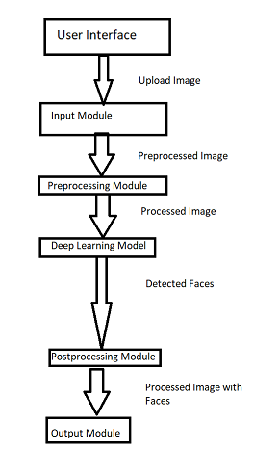

# Figure 3.1: System Architecture

# HARDWARE REQUIREMENTS:

|  |  |
| --- | --- |
| **SYSTEM** | INTEL i3 Processor |
| **HARD DISK** | 256 GB |
| **MONITOR** |  |
| **INPUT DEVICES** | Keyboard, Mouse |
| **RAM** | 2 GB |

# SOFTWARE REQUIREMENTS:

|  |  |
| --- | --- |
| **REQUIREMENTS** | **SPECIFICATIONS** |
| TOOL | GOOGLE COLAB |
| CODING LANGUAGE | PYTHON |
| OPERATING SYSTEM | WINDOWS 10 |

# PYTHON:

Python is an interpreted, object-oriented, high-level programming language with dynamic semantics. Its high-level built-in data structures, combined with dynamic typing and dynamic binding, make it very attractive for Rapid Application Development, as well as for use as a scripting or glue language to connect existing components together. Python's simple, easy to learn syntax emphasizes readability and therefore reduces the cost of program maintenance. Python supports modules and packages, which encourages program modularity and code reuse. The Python interpreter and the extensive standard library are available in source or binary form without charge for all major platforms, and can be freely distributed.

# JUPYTER NOTEBOOK:

Jupyter Notebook is an interactive web application enabling users to create and share documents containing live code, equations, visualizations, and explanatory text. Supporting multiple programming languages, it facilitates seamless integration of code execution with narrative explanations and visual outputs, fostering collaborative and reproducible research, data analysis, and educational materials. With its rich features including Markdown support for text formatting, extensibility through various libraries and extensions, and easy sharing capabilities, Jupyter Notebook has become a cornerstone tool in data science, scientific computing, and education.

# CHAPTER 4

**IDEATION AND BRAISTORMING**

The ideation and brainstorming phase involved exploring various approaches and techniques to tackle the problem of face detection, effectively. Here are some key ideas and considerations that guided the development process:

**Choice of Deep Learning Model:**

Brainstorm and research different deep learning models suitable for face detection,

considering factors such as model complexity, accuracy, inference speed, and

compatibility with the project's requirements.

**Data Collection and Preparation:**Ideate strategies for collecting diverse face detection datasets, including methods to ensure representation across various facial expressions, poses, lighting conditions, and demographics. Consider data augmentation techniques to enrich the dataset.

**Preprocessing Techniques:**

Brainstorm preprocessing methods such as image resizing, normalization, noise reduction,

and occlusion handling to prepare input images for optimal performance during

face detection.

**Model Training and Optimization:**

Brainstorm training strategies, hyperparameter tuning approaches, and optimization

techniques to train the chosen deep learning model effectively. Consider transfer learning

from pre-trained models and regularization methods for model generalization.

**Real-Time Processing:**

Brainstorm solutions to achieve real-time face detection performance, including hardware

acceleration (e.g., GPU), model optimization (e.g., quantization), and efficient inference

pipelines (e.g., batch processing).

**Accuracy and Robustness:**

Brainstorm ways to improve accuracy and robustness in face detection, such as multiscale

detection, ensemble models, post-processing techniques (e.g., NMS), and handling

challenging scenarios like occlusions or partial detections.

**User Interface and Experience:**

Ideate on designing a user-friendly interface for the face detection system, considering

features like image upload functionality, parameter adjustments, real-time feedback,

confidence scores, and result visualization.

**Integration with External Systems:**

Brainstorm integration possibilities with external systems or APIs for additional

functionalities such as face recognition, emotion detection, gender estimation, or database

interactions. Consider interoperability and data exchange protocols.

**Testing and Evaluation:**

Brainstorm testing scenarios, validation strategies, and evaluation metrics (e.g., precision,

recall, F1-score, processing speed) to assess the performance and effectiveness of the face

detection system.

**Ethical and Privacy Considerations:**

Consider ethical implications and privacy concerns related to face detection technology,

brainstorming strategies for data privacy, consent management, bias mitigation,

responsible AI practices, and compliance with regulatory standards.

# CHAPTER 5

**REQUIREMENT ANALYSIS**

The requirements analysis phase involves identifying and specifying the functional and non-functional requirements of the face detection in image project. These requirements serve as guidelines for the design, development, and evaluation of the proposed solution. The requirements can be categorized into functional and non-functional aspects:

**5.1 FUNCTIONAL REQUIREMENTS**

|  |  |  |
| --- | --- | --- |
| **S.No** | **Metrics** | **Description** |
| FR1 | User should be able to upload images for face detection. | Implement a file upload functionality in the user interface to allow users to select and upload images for processing. |
| FR2 | System should resize uploaded images for processing. | Use OpenCV's image resizing functions to resize uploaded images to a standard size suitable for deep learning model input |
| FR3 | Implement error handling for file upload and processing. | Include error checks to handle scenarios such as no file uploaded, error loading images, or exceptions during the face detection process. |
| FR4 | Allow users to interact with displayed images. | Optionally, enable zooming, panning, or clicking on faces to display additional information (e.g., confidence scores, face attributes). |
| FR5 | Deep learning model should detect faces in images. | Integrate a pre-trained deep learning model (e.g., SSD, YOLO) using OpenCV's DNN module to perform face detection on the uploaded images. |
|  |  |  |

**5.2 NON-FUNCTIONAL REQUIREMENTS**

|  |  |  |
| --- | --- | --- |
| **S.No** | **Requirement** | **Description** |
| NFR1 | System Performance: | Ensure the face detection system can process images efficiently, with minimal latency, to provide near real-time results.. |
| NFR2 | Accuracy and Reliability: | Aim for high accuracy in detecting faces, minimizing false positives and negatives, to ensure reliable results. |
| NFR3 | Scalability: | Design the system to handle varying loads, such as processing multiple image uploads simultaneously or handling large image datasets.. |
| NFR4 | Security and Privacy | Ensure data privacy and security by implementing secure file upload mechanisms, protecting user data during processing and storage. |
| NFR5 | Compatibility and Portability | Ensure compatibility with different platforms and browsers for seamless deployment and use across various environments. |
| NFR6 | Documentation and Support: | Provide comprehensive documentation, including user guides and technical documentation, and offer support for users as needed. |

# CHAPTER 6

# SYSTEM MODELING

**6.1 UNIFIED MODELING LANGUAGE(UML):**

The Unified Modeling Language (UML) diagram for the face detection project encompasses several key classes and their relationships, offering a structured representation of the system's architecture. The diagram includes classes such as InputModule, PreprocessingModule, DeepLearningModel, Postprocessing, OutputModule, and UserInterfaceModule, each fulfilling specific functionalities within the face detection system.

The InputModule class manages input sources, facilitating image upload and retrieval. It interacts with the PreprocessingModule, responsible for preparing input images by performing operations like resizing and normalization. The DeepLearningModel class encapsulates the deep learning model used for face detection, with methods for loading the model, performing inference, and detecting faces within images. It collaborates with the Postprocessing class, which refines the output by applying techniques such as Non-Maximum Suppression (NMS) to filter detections.

The OutputModule class handles the display and saving of processed images, ensuring the results are presented to the user in a clear and accessible manner. The UserInterfaceModule enhances user interactions by providing a graphical interface for adjusting parameters, visualizing metadata about detected faces, and displaying the final results.

Overall, the UML diagram captures the structural components and their relationships within the face detection system, illustrating a cohesive architecture designed to efficiently detect faces using deep learning techniques while offering a seamless user experience.

# 

# 6.2 USE CASE DIAGRAM:

In the Use Case Diagram for the face detection project, various actors and their interactions with the system are depicted, highlighting the functional requirements and user roles within the application. The diagram includes actors such as User, System, and External API, along with use cases representing specific actions or functionalities.

The User actor interacts with the system through use cases such as Upload Image, Adjust Parameters, and View Results. The Upload Image use case allows users to upload images for face detection, triggering the processing and analysis of the uploaded image within the system. The Adjust Parameters use case enables users to customize settings related to the face detection process, such as confidence threshold or detection mode. The View Results use case allows users to visualize the detected faces and associated metadata, providing feedback and insights into the detection outcomes.

The System actor encapsulates the core functionalities of the face detection system, including use cases such as Detect Faces, Preprocess Image, Postprocess Results, and Display Results. The Detect Faces use case represents the algorithmic process of identifying faces within an image using deep learning models. The Preprocess Image use case involves preparing the input image for analysis, while the Postprocess Results use case refines the detected faces output. The Display Results use case showcases the processed images with detected faces to the user interface.

Additionally, the External API actor interacts with the system through the Integrate with External Systems use case, facilitating integration with external services or APIs for functionalities like face recognition or database interactions. This use case demonstrates the system's ability to collaborate and exchange data with external systems seamlessly.

Overall, the Use Case Diagram captures the functional requirements, user interactions, and system capabilities of the face detection project, providing a comprehensive overview of the application's use cases and actor roles.

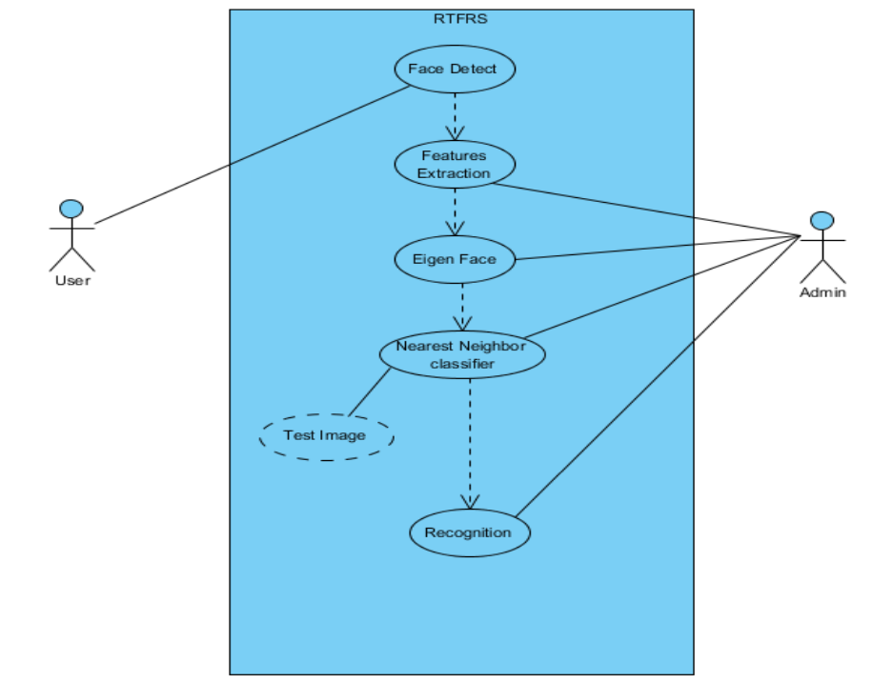

# Figure 4.2: Use case diagram

# 6.3 CLASS DIAGRAM:

The Class Diagram for the face detection project represents the various classes and their relationships within the system, providing a structural overview of the system's architecture and components. Here is a description of the classes and their roles:

**InputModule:**

Manages input sources such as uploaded images or video streams.

Responsibilities include handling file uploads and providing input to the preprocessing module.

**PreprocessingModule:**

Prepares input images for face detection by performing operations like resizing, normalization, and format conversion.

Collaborates with the InputModule to receive and process input images before passing them to the deep learning model.

**DeepLearningMode**l:

Represents the core deep learning model used for face detection tasks.

Responsibilities include loading the pre-trained model, performing inference to detect faces, and providing detection results.

**Postprocessing:**

Refines the output of the deep learning model by applying post-processing techniques such as Non-Maximum Suppression (NMS) to filter and refine face detections.

Collaborates with the DeepLearningModel to enhance the accuracy and quality of detected faces.

**OutputModule:**

Manages the output and presentation of processed images with detected faces to the user interface.

Responsibilities include displaying processed images, saving results, and providing options for user interaction with the detected faces.

**UserInterfaceModule:**

Facilitates user interactions and provides a graphical interface for users to interact with the face detection system.

Responsibilities include adjusting parameters, visualizing metadata about detected faces, and displaying the final results to users.

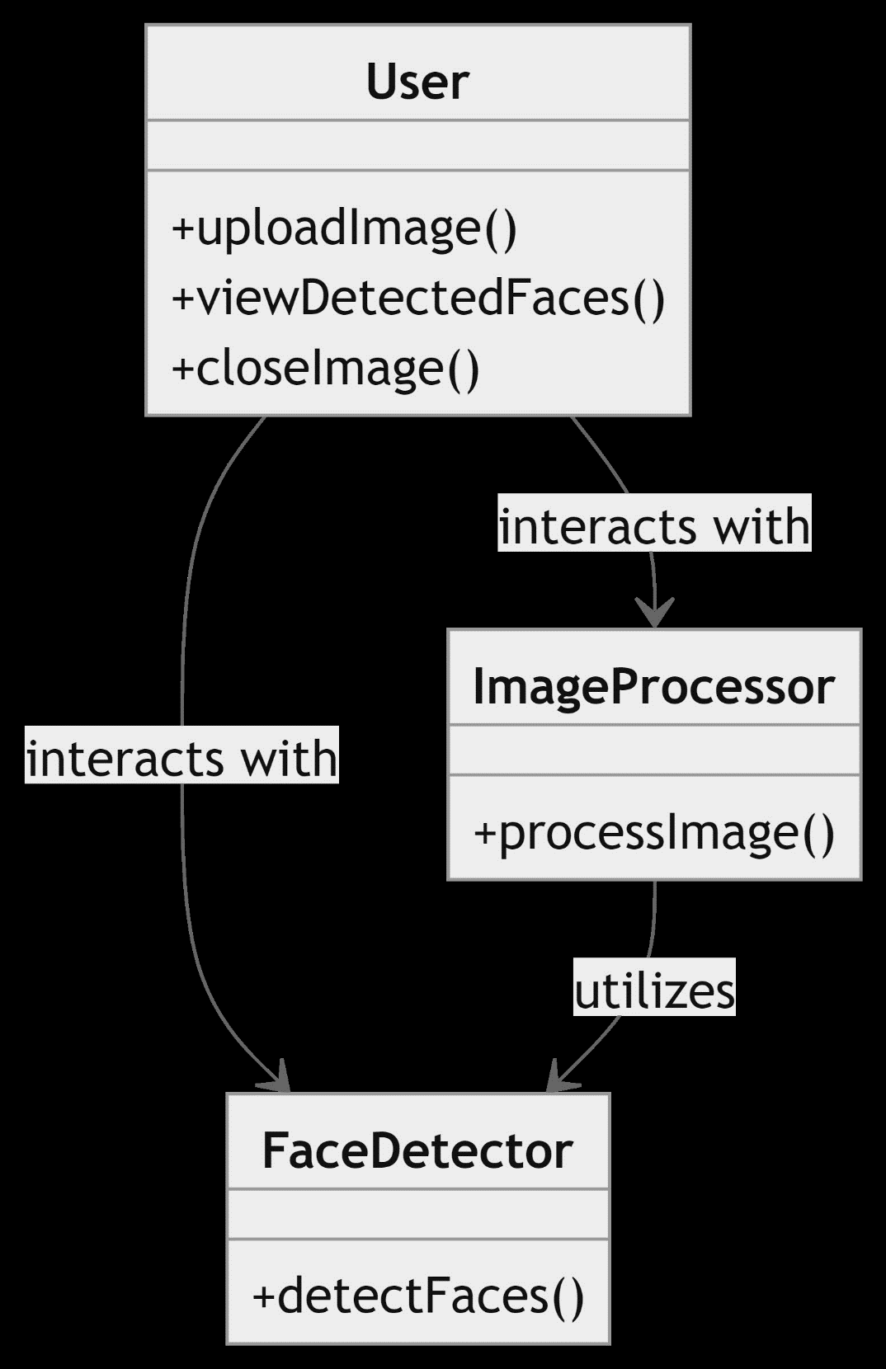

# Figure 4.3 : Class Diagram

# 6.4 SEQUENCE DIAGRAM

The Sequence Diagram for the face detection project illustrates the interactions and flow of messages between various components and modules during the execution of face detection tasks. Here is a description of the sequence of events depicted in the diagram:

**User Uploads Image:**

The sequence begins when the user uploads an image to the system through the User Interface Module.

The Input Module receives the uploaded image and passes it to the Preprocessing Module for initial processing.

**Image Preprocessing:**

The Preprocessing Module performs operations like resizing, normalization, and format conversion on the input image to prepare it for face detection.

Once preprocessing is complete, the preprocessed image is sent to the Deep Learning Model for face detection.

**Face Detection Process:**

The Deep Learning Model loads the pre-trained face detection model and executes the inference process on the preprocessed image.

During inference, the model detects faces within the image and generates detection results.

**Postprocessing and Output:**

The Postprocessing Module refines the detection results using techniques like Non-Maximum Suppression (NMS) to filter redundant detections and improve accuracy.

The refined detection results, along with metadata about the detected faces, are passed to the Output Module for display.

**Display Results to User:**

The Output Module presents the processed image with bounding boxes around detected faces to the User Interface Module.

The User Interface Module displays the final results to the user, allowing them to view the detected faces, adjust parameters, and interact with the system.

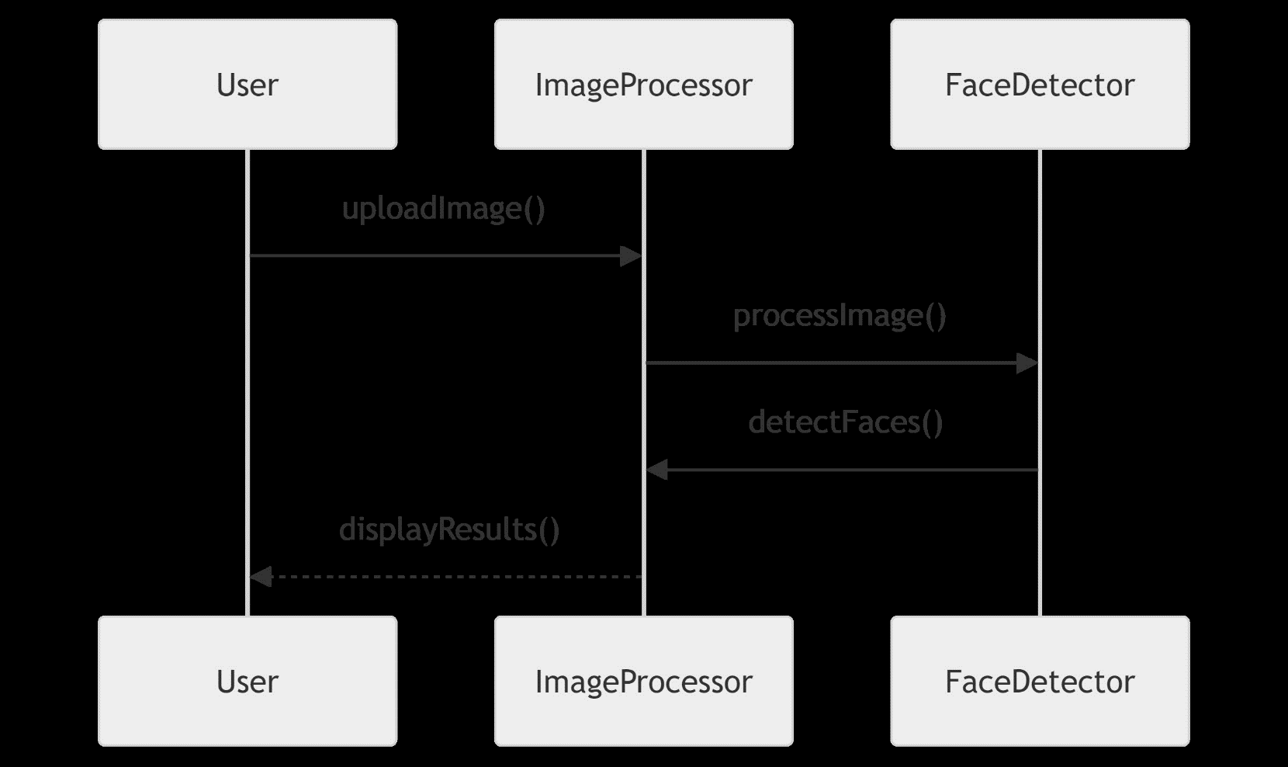

# Figure 4.4: Sequence Diagram

# 6.5 ACTIVITY DIAGRAM

The Activity Diagram for the face detection project outlines the sequential flow of activities and actions within the system, starting from the user's interaction to the final display of detected faces. Here is a description of the activities depicted in the diagram:

**User Interaction:**

The activity diagram begins with the User interacting with the system, either by uploading an image or providing input through the user interface.

**Input Processing:**

Upon receiving user input, the system initiates the process of input processing, which includes activities like checking the input format, validating the image, and passing it to the preprocessing module.

**Preprocessing:**

The Preprocessing Module performs activities such as image resizing, normalization, and format conversion to prepare the input image for face detection.

**Face Detection:**

The system executes the Face Detection activity using the Deep Learning Model, which involves loading the model, performing inference on the preprocessed image, and detecting faces within the image.

**Postprocessing:**

After face detection, the system engages in postprocessing activities like refining the detection results, applying Non-Maximum Suppression (NMS) to eliminate redundant detections, and generating metadata about the detected faces.

**Output Display:**

The final activity involves displaying the processed image with bounding boxes around detected faces to the user interface through the Output Module.



# Figure 4.5: Activity diagram

# 

# 6.6 STATE CHART DIAGRAM

The State Chart Diagram for the face detection project outlines the various states that the system can be in and the transitions between these states triggered by events. In this diagram, the system starts in the Idle state, representing its initial waiting state for user input or image upload. When the user uploads an image or triggers the detectFaces() event, the system transitions to the Detecting state, indicating that the face detection process is active. Once the face detection algorithm successfully identifies faces within the image, the system transitions to the Detected Faces state, signifying that the faces have been processed and ready for display or further interaction. This State Chart Diagram captures the dynamic behavior of the face detection system, highlighting the states and transitions involved in processing user input and detecting faces within images.

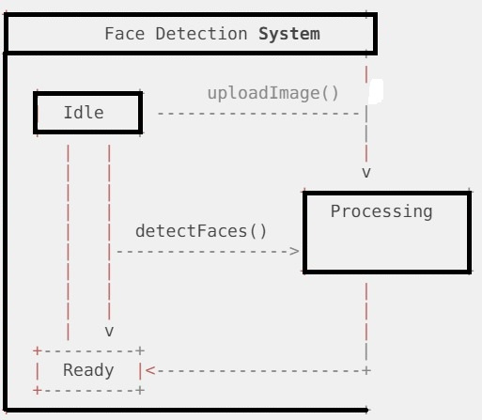

# Figure 4.8: Statechart Diagram

**CHAPTER 7**

# SYSTEM IMPLEMENTATION

# 7.1 PROPOSED SYSTEM

The proposed system for face detection aims to leverage advanced deep learning techniques to enhance accuracy, speed, and robustness compared to traditional methods. Key components of the proposed system include:

**1.Advanced Deep Learning Models:**

Utilize state-of-the-art deep learning models such as SSD (Single Shot Multibox Detector), Faster R-CNN (Region-based Convolutional Neural Network), or RetinaNet for accurate and efficient face detection.

**2.Multi-Stage Processing:**

Implement a multi-stage processing pipeline, including preprocessing, deep learning-based detection, and post-processing steps like Non-Maximum Suppression (NMS) to refine and filter detected faces.

**3.Real-Time Processin**g:

Optimize the system for real-time processing by leveraging GPU acceleration, model optimization techniques, and efficient inference pipelines to achieve fast and responsive face detection performance.

**4.Enhanced Accuracy and Robustness:**

Address challenges such as occlusions, varying lighting conditions, and pose variations by incorporating ensemble models, multi-scale detection strategies, and advanced post-processing techniques for improved accuracy and robustness.

**5.User-Friendly Interface:**

Design a user-friendly interface with features for uploading images, adjusting detection parameters (e.g., confidence threshold), visualizing detection results with bounding boxes, and displaying metadata about detected faces.

**6.Integration with External Systems:**

Enable seamless integration with external systems or APIs for additional functionalities like face recognition, emotion detection, gender estimation, or database interactions, enhancing the system's capabilities and versatility.

**7. Ethical Considerations:**

Prioritize ethical considerations such as data privacy, consent management, bias mitigation, fairness, and responsible AI practices throughout the development and deployment of the face detection system.

**7.2 SOURCE CODE :**

import cv2

from google.colab import files

from google.colab.patches import cv2_imshow

import numpy as np

!wget https://github.com/opencv/opencv/raw/master/samples/dnn/face_detector/deploy.prototxt

!wget https://github.com/opencv/opencv_3rdparty/raw/dnn_samples_face_detector_20170830/res10_300x300_ssd_iter_140000.caffemodel

def detect_faces_and_display(image):

try:

prototxt_path = "deploy.prototxt"

model_path = "res10_300x300_ssd_iter_140000.caffemodel"

net = cv2.dnn.readNetFromCaffe(prototxt_path, model_path)

resized_image = cv2.resize(image, (300, 300))

blob = cv2.dnn.blobFromImage(resized_image, 1.0, (300, 300), [104, 117, 123], False, False)

net.setInput(blob)

detections = net.forward()

for i in range(detections.shape[2]):

confidence = detections[0, 0, i, 2]

if confidence > 0.5:

box = detections[0, 0, i, 3:7] * np.array([image.shape[1], image.shape[0], image.shape[1], image.shape[0]])

(startX, startY, endX, endY) = box.astype(int)

cv2.rectangle(image, (startX, startY), (endX, endY), (0, 255, 0), 2)

cv2_imshow(image)

cv2.waitKey(0)

cv2.destroyAllWindows()

except Exception as e:

print("Error:", e)

def main():

try:

uploaded = files.upload()

if len(uploaded) == 0:

raise ValueError("No file uploaded")

file_name = list(uploaded.keys())[0]

image = cv2.imread(file_name)

if image is None:

raise ValueError("Error loading image")

detect_faces_and_display(image)

except ValueError as ve:

print("ValueError:", ve)

except Exception as e:

print("Error:", e)

if __name__ == "__main__":

main()

# CHAPTER 8 PROJECT DESIGN

# 8.1 DATA FLOW DIAGRAM



# CHAPTER 9

**ADVANTAGES AND DISADVANTAGES**

# 9.1 ADVANTAGES

**High Accuracy:**

Deep learning models can achieve high accuracy in detecting faces, especially when trained on large and diverse datasets.

**Efficiency:**

The system can process images quickly, making it suitable for real-time or near real-time applications.

**Flexibility:**

It can be customized and extended with additional features like emotion detection or gender classification.

**User-Friendly:**

The user interface allows for easy image upload and interaction, enhancing user experience.

**Practical Applications:**

It has diverse applications in security systems, image analysis, social media platforms, and more.

# 9.2 DISADVANTAGES

**Complexity:**

Implementing deep learning models and integrating them with OpenCV can be complex and require expertise.

**Resource Intensive:**

Deep learning models may require significant computational resources, such as CPU/GPU power and memory.

**Dependency on Data:**

The accuracy of the system heavily depends on the quality and diversity of the training data for the deep learning model.

**False Positives/Negatives:**

Like any automated system, there can be instances of false positives (incorrectly detecting faces) or false negatives (missing actual faces).

**Security and Privacy Concerns:**

Face detection systems may raise privacy concerns if not implemented securely, especially in sensitive applications.

# CHAPTER 10

**CONCLUSION AND FUTURE ENHANCEMENT**

# 10.1 CONCLUSION

the development of an automated face detection system using deep learning and OpenCV presents a powerful solution for various applications requiring accurate and efficient face detection. Despite challenges such as complexity and resource usage, the advantages including high accuracy, flexibility, and practical applications outweigh the disadvantages. This project highlights the potential of deep learning in enhancing computer vision capabilities and underscores the importance of addressing challenges to ensure optimal performance and user satisfaction in face detection technology.

# 10.2 FUTURE ENHANCEMENT:

**Multi-Face Recognition:**

Enhance the system to not only detect faces but also recognize individuals based on facial features, enabling applications like personalized content delivery or access control.

**Emotion Detection:**

Integrate emotion detection capabilities to identify facial expressions such as happiness, sadness, anger, etc., providing insights into user sentiment and enhancing user experience.

**Age and Gender Estimation:**

Extend the system to estimate the age and gender of detected faces, enabling demographic analysis and targeted marketing strategies.

**Pose Estimation:**

Incorporate pose estimation algorithms to detect and analyze the pose or orientation of faces in images, useful for applications like pose correction in photography or virtual try-on experiences.

**Real-Time Video Analysis:**

Expand the system's capabilities to perform real-time face detection and analysis in video streams, suitable for applications like surveillance, video analytics, or live streaming platforms.

**Integration with IoT Devices:**

Integrate the face detection system with IoT devices such as smart cameras or wearables for seamless interaction and automation in smart home or smart city environments.

**Deep Learning Model Optimization:**

Continuously optimize deep learning models and algorithms for improved accuracy, speed, and efficiency, leveraging advancements in model architectures and training techniques.

**Enhanced Privacy Features:**

Implement advanced privacy features such as data anonymization, encryption, and user consent mechanisms to ensure compliance with data protection regulations and enhance user trust.

**Multi-Modal Biometric Authentication:**

Explore the integration of face detection with other biometric modalities like fingerprint or iris recognition for multi-modal biometric authentication systems with enhanced security.

**Customizable Workflows:**

Provide users with customizable workflows and configurations for face detection tasks, allowing them to tailor the system to their specific use cases and preferences.

# APPENDIX SCREENSHOTS

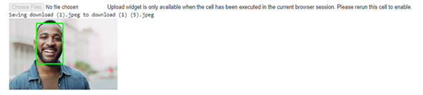

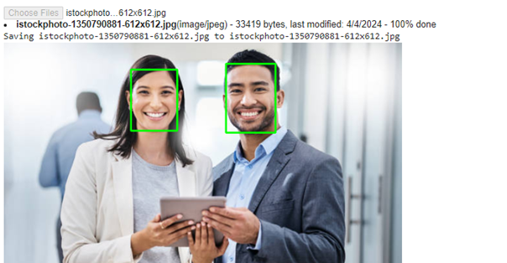

**REFERENCES:**

Viola, P., & Jones, M. J. (2004). Robust real-time face detection. International Journal of Computer Vision, 57(2), 137-154.

Yang, J., Luo, P., Loy, C. C., & Tang, X. (2016). WIDER FACE: A face detection benchmark. In Proceedings of the IEEE conference on computer vision and pattern recognition (pp. 5525-5533).

Redmon, J., Divvala, S., Girshick, R., & Farhadi, A. (2016). You only look once: Unified, real-time object detection. In Proceedings of the IEEE conference on computer vision and pattern recognition (pp. 779-788).

Lin, T. Y., Goyal, P., Girshick, R., He, K., & Dollár, P. (2017). Focal loss for dense object detection. In Proceedings of the IEEE international conference on computer vision (pp. 2980-2988).

**GITHUB LINK:** https://github.com/ArunMsecollege/Generative-AI